Relationships and Sexuality Education (RSE) Policy

STEBONHEATH SCHOOL


Date of implementation | September 2023
Date of policy review | September 2024
Name of RSE Lead | Julian Littler & Kath Williams

Introduction

RSE is a positive and protective part of the Curriculum for Wales. It plays a central role in supporting learners’ rights to enjoy fulfilling, healthy and safe relationships throughout their lives. RSE is also a key part of our safeguarding role at Stebonheath School.

Central to the Curriculum for Wales is an aspiration for every child and young person to achieve the four purposes of the curriculum. A rights and equity based RSE curriculum helps ensure that all learners can develop an understanding of how people’s faith, beliefs, human rights and cultures are related to all aspects of RSE and how these rights can contribute to the freedom, dignity, well-being and safety of all people. Therefore, within Stebonheath School, we will discuss RSE in the context of the Rights protected by the United Nations Convention on the Rights of the Child.

RSE at Stebonheath School will support learners to develop the knowledge, skills and values to understand how relationships shape their lives as well as the lives of others. Learners will be equipped and empowered to seek support on issues relating to RSE and to advocate for self and others.

Within the Curriculum for Wales, Welsh Government have legislated that RSE is a mandatory requirement for all learners from age 3 to 16 (“the Act”). This means that all learners must receive this education and that there is no right for parents/ carers to withdraw their children from RSE.

This policy has been written in accordance with the Curriculum and Assessment (2021) Act; link here.

Developmentally appropriate RSE

The Act requires that the RSE provided must be developmentally appropriate for learners. Therefore, schools and settings must take account of a range of factors such as the learners age, knowledge and maturity and any additional learning needs. RSE at Stebonheath School will be developmentally appropriate for each learner. The age of learners should be one of the criteria by which practitioners decide upon the appropriateness of content; however, there will be other factors they will need to consider when planning provision. Factors such as the physical and mental and emotional development of learners should also be taken into account. This is essential to ensuring learners are kept safe from information for which they are not sufficiently mature to process. This, however, should not be a reason for not providing children and young people with the essential information they need as they develop physically, mentally and emotionally; developmentally appropriate RSE requires the coverage of subjects that are integral to learners’ development. For example, issues which may affect some younger learners, such as puberty and menstruation, should be engaged with sensitively and before the onset of physiological changes. We will also consider how appropriate support is provided through a whole school approach such as, in the case of puberty, ensuring that learners have access to sanitary products.

Children’s Rights

Learning in RSE should highlight the right to:

Protection of the body
- Every child has a right to have their body respected and treated gently.
- No child should have their body hurt by anyone.
- A child‘s private parts are private.

To kindness
- Every child has the right to be valued and treated with kindness.
- Every child has the right to be greeted and related to warmly.
- No child should be hurt with cruel words.
- If a child is doing something an adult thinks is wrong, the child has the right to be told this in a gentle, non-frightening way.

To respect and acknowledgement
- Every child has the right to be respected.
- Every child has the right for adults at home and school to know what matters to him or her.
- Every child has the right for adults at home and school to know what makes him or her feel happy and unhappy.
- No child should be laughed at, humiliated or made to feel ashamed.
- Every child has the right to say when they feel they have been shamed.

To suitable learning
- Every child has the right to be challenged in their learning, but never to be given work that makes them feel they are not good enough.
- Every child has the right to have adults be curious about their interests and what they want to learn more about.
- Every child has a right to help from teachers in school, if something at home or elsewhere is stopping them from learning.
To feel safe and not be frightened
- Every child has the right to feel safe at home, school and anywhere else, including on-line.
- No child should be frightened by anyone at home, school or anywhere else, including on-line.
- Every child has the right to ask a kind adult for help if they feel frightened, unsafe or unsure in any way.
- Every child has the right to say ‘No’ and ‘Stop’ and have this respected.

Having a voice and being heard
- Every child has the right to feel their voice is heard in a way that makes a difference and respects the fact that they are a citizen of the world.
- Every child has the right to ask for help if something in their life is stopping them from learning.
- Every child has the right to be helped by a kind adult to find the right words when they don’t feel safe.
- Every child has the right to say if someone is being cruel to them or someone they care about, so that the cruelty can be stopped.
- Every child has the right to be supported to learn about all their child rights as well as knowing about the rights of others.
Thanks to Trauma Informed Schools for allowing this to be shared.

UNCRC Article 3: everyone who works with children should always do what is best for each child, is relevant to RSE, as it is to the whole curriculum.

Related Policies

The RSE policy has been written to link with other school policies and processes at Stebonheath School. These include:

- Safeguarding and child protection
- Behaviour policy
- Anti-bullying policy
- IT/Online safety policy
- Equalities Policy

This RSE Policy aligns with the Equality Act 2010 under which schools must not unlawfully discriminate against learners on the basis of their age, sex, race, disability, religion or belief, gender reassignment, pregnancy or maternity, marriage or civil partnership, or sexual orientation (collectively known as protected characteristics).

Aims and objectives of RSE

The aim of RSE at Stebonheath School is to give young people the information they need to help them develop & maintain healthy, nurturing relationships of all kinds. It should enable them to know what a healthy relationship looks like. It should teach what acceptable and unacceptable behaviour in relationships is.

In accordance with legislation, RSE at Stebonheath School will be inclusive, factually correct and provide opportunities for learners to critically engage and respond to all areas of the RSE curriculum, within a safe environment. Staff will be well trained and all resources used will be carefully selected in line with the needs of the learners.
RSE will be taught through the Health and Wellbeing area of learning via discreet RSE lessons.

Co-constructing with pupils

In accordance with the United Nations Convention for the Rights of the Child, pupil voice will be considered to support in constructing the RSE curriculum at Stebonheath School and pupils will regularly have opportunities to evaluate and review our RSE provision to ensure that it effectively meets their needs.

Working with parents/carers

All parents/ carers will be kept informed about the provision of RSE at Stebonheath School and will be encouraged to see RSE as a shared responsibility between school and home.

Working with visitors and external agencies

When visitors and external agencies provide sessional learning opportunities for learners, the school will ensure that:

- The school and the external provider have agreed the aims, content and approach to be adopted.
- The local authority (education department) know of and have approved the agency as a provider of RSE support within schools.
- The school has made the provider aware of any relevant school policies.
- The school has informed and prepared pupils ahead of the visit and allowed them time to prepare questions, if appropriate.
- Contributions by external agencies are followed up and always form part of a whole school approach
- Schools who commission external agencies will apply and follow the safe recruitment and commissioning procedures of the local authority.
- The school has planned for the provider to be actively supported by a teacher throughout the visit.

Monitoring RSE

Although RSE is a whole school responsibility, RSE will be monitored, reviewed and evaluated by those with responsibility for RSE at Stebonheath School, in line with the school’s curriculum policy. This includes:

- The representative from the Governing body with responsibility for the Health & Wellbeing AoLE
- The Headteacher and Senior Leadership Team
- The Health & wellbeing AoLE
- Pupils

This RSE policy will be reviewed every year and this process will include all of the above, alongside other members of our school community (parents/ carers, the Governing body and pupils) to ensure that our RSE provision and curriculum is effective in meeting our statutory requirements.

Ratified by:

Chair of Governors: 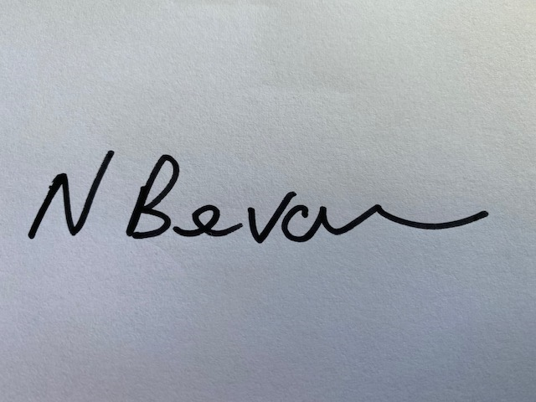

Head Teacher: 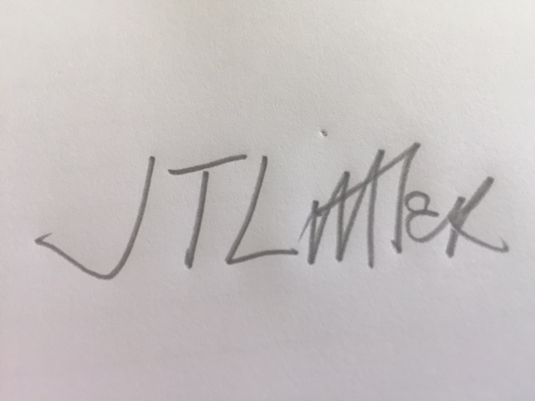

Autumn Term 2023

To be reviewed: Autumn Term 2024

