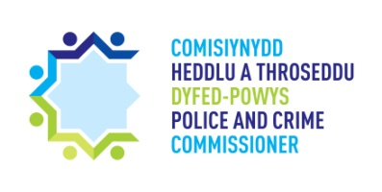
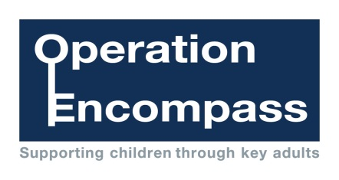
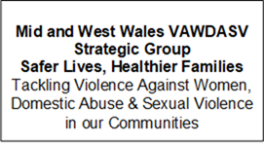
Dear Parent/Carer,
The school has been given the opportunity to take part in a project that will run jointly between schools and Dyfed-Powys Police. It is a county wide initiative across all schools in Carmarthenshire.
Operation Encompass is the reporting to schools, prior to the start of the next school day, when a child or young person has been exposed to, or involved in, any domestic incident.
Operation Encompass will ensure that a member of the school staff, known as a Key Adult, is trained to use the information that has been shared with them about the domestic incident. This is to ensure that a child is adequately supported and/or their families, who have been involved in, or exposed to, a domestic abuse incident.
We are keen to offer the best support possible to all our pupils and we believe this will be extremely beneficial for all those involved.
Yours sincerely,
Mr J T Littler
Head Teacher


